The Litchfield Pioneer Family in Elk City, Idaho

On August 2, 1888, John Charles Litchfield and his wife, Sarah Elizabeth, brought their four children to Elk City, Idaho from Butte, Montana. They said later that they found about a dozen white men and 400 Chinese miners in the area, and that tree stumps still studded Elk City’s Main Street.

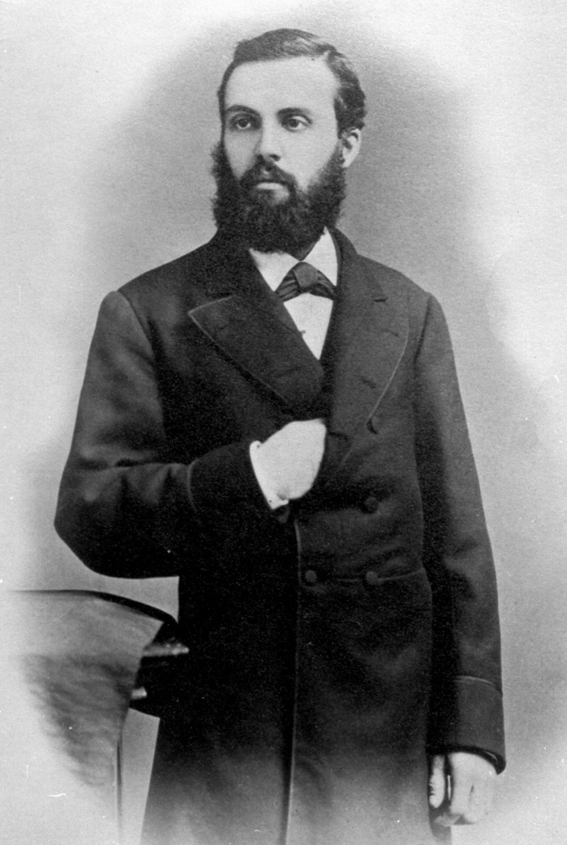
They came because Sarah’s brother, Samuel Watkins “Buster” Smith, had been in Elk City since 1884, developing an underground “quartz” gold mine that showed great promise. He had named it after himself -- the Buster Mine. The Litchfields claimed later that Buster had promised John Charles employment at the mine and a share in the riches. Little did they know that their fortunes and even their lives would rise and fall with Elk City's quartz-mining boom.

John Charles Litchfield was born in Peterborough, England on 29 May 1854. In his twenties, “J.C.,” as he was called, was a sailor in the Royal Navy. In 1880 his ship, the broadside ironclad battleship H.M.S. Triumph, stopped in San Francisco, where J.C. met and fell in love with Sarah Elizabeth Smith, a local girl whose parents were English. J.C. soon sailed with his ship to Vancouver, B.C., but couldn’t bear to leave Sarah. He jumped ship and returned to San Francisco to marry her on 20 Jul 1880.
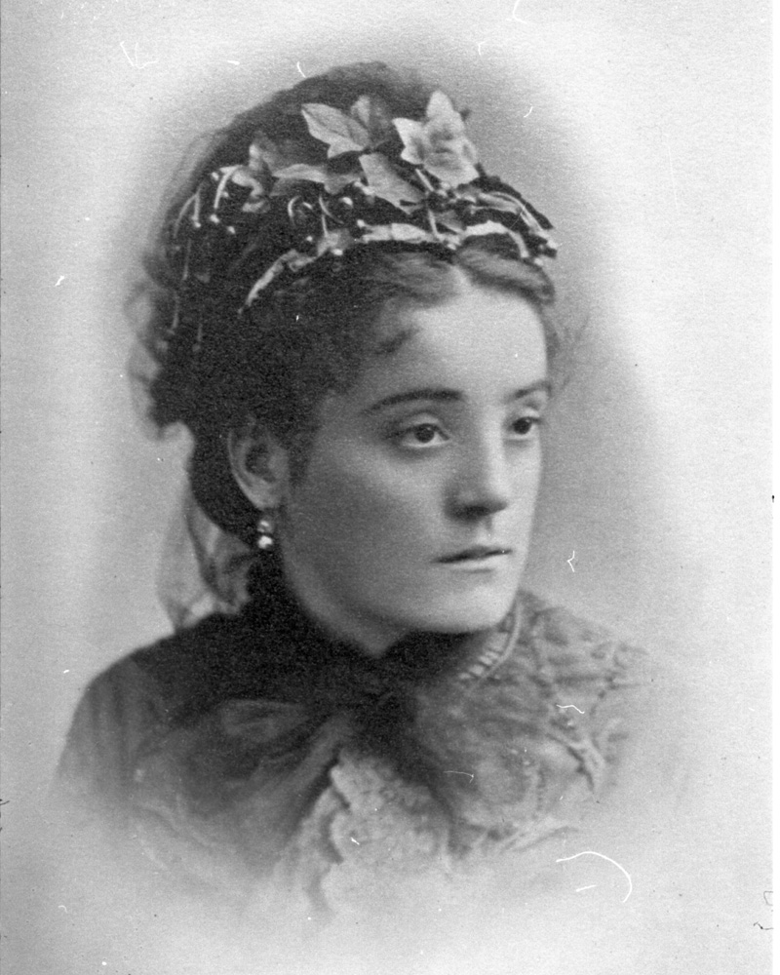
Sarah Elizabeth Smith was born on 8 Nov 1857 in San Francisco, to parents born in England. She was interested in books and music, and believed in maintaining a nice home. After she married J.C., they lived at first in San Francisco and then in West Oakland, California. But in those years, the ’49 Gold Rush was still fueling the hopes of many people. Sarah’s older brother Buster was already a mine superintendent, and her younger brother James was an assayer. Buster was actively seeking a place where he could make a big strike. Sarah and J.C. got caught up in his enthusiasm and followed the mining fever to Butte and then to Elk City.

When J.C. and Sarah came to Elk City in August, 1888, they brought with them their first four children -- two boys and two girls:

William Grant, born 12 Jul 1881 in San Francisco, California.
Stanley Watkins, born 15 Feb 1883 in West Oakland, California.
Noël Arden, born 25 Dec 25, 1884 in West Oakland, California.
Alma Allen, born 6 Aug 1886 in Butte, Montana.

The family came to Elk City on horseback, even though the two girls were quite young for such an arduous journey. They almost certainly came over the Southern Nez Perce trail (now much improved, and called “The Magruder Road” or “Montana Road”), because there was no railroad through the northern Rockies until 18 years later , and the only other alternative would have been an incredibly long and circuitous wagon ride.

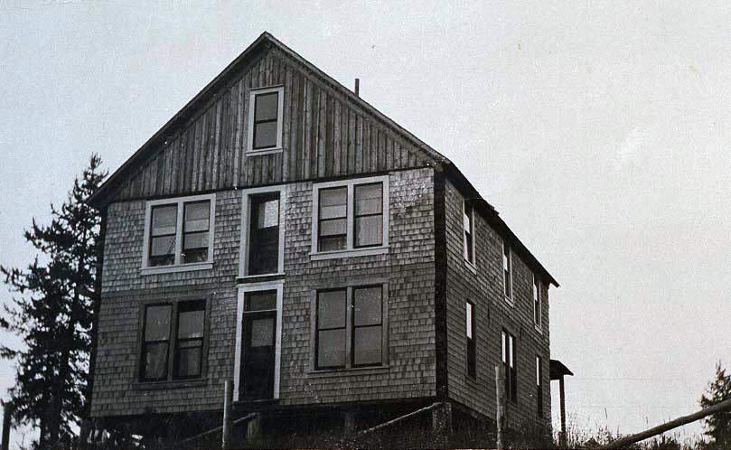
There doesn’t seem to be a record of where the Litchfields lived when they arrived in the Elk City area, but within a few years they were living just north of Big Elk Creek, from its confluence with Little Elk Creek upstream for most of a mile. J.C. built a rather large but stark, two-story house on a rise overlooking the confluence. Stanley homesteaded west of this, just north of the present-day bridge that carries Elk Creek Road over Big Elk Creek. Grant homesteaded northwest of Stanley, on both sides of present-day Elk Creek Road.

Fourteen months after the family arrived in Elk City, on 30 Oct 1889, Sarah gave birth to her fifth child, a boy. He was said to be the first white boy born in Elk City, so they named him Idaho Charles Litchfield. Less than four years later, on 11 May 1893, John Arden came into the world, the fourth and last son of the family. He was followed by two more girls -- Ruth Elizabeth, born 13 Jul 1895; and Sarah Helen Lee, called “Helen,” born 4 Sep 1898.

That made a large but balanced family, with four boys and four girls.

J.C. kept busy supporting his family. He hauled freight and built mine and mill buildings. There appear to be no surviving records of his involvement, if any, in the Buster Mine owned by his brother-in-law.

Sarah Litchfield was instrumental in restarting the Elk City School in 1895. There were seven pupils the first year: five Litchfield children, another child, and the 41-year-old Chinese miner, Lee Mann.

Those were heady times in the Elk City area. The early success of the Buster Mine, followed by the Colonel Sellers and American Eagle Mines, led to a new gold rush.

Idaho County Free Press, September 7, 1888:
H.E. Reynolds, of the firm Mooney, Reynolds, and Pierce, is out from Elk City laying in their winter supply. He says that Elk City is lively and is the coming camp.

Idaho County Free Press, January 18, 1889:
Now that our railroad prospects are somewhat indefinite we ought to turn our attention towards building wagon roads into Elk City and Warren.

Idaho County Free Press, October 22, 1897:
J.C. Litchfield of Elk City was in town Tuesday. He has just completed erection of the Badger quartz mill and is now in Dixie, putting up the mill for the Idaho Comstock Company.

Idaho County Free Press, September 21, 1901:
Elk City -- This famous old mining camp will soon be in telephone communication with the outside world. George W. Goode, who recently opened his line from Grangeville to White Bird, is now pushing the wires in the direction of Elk City.

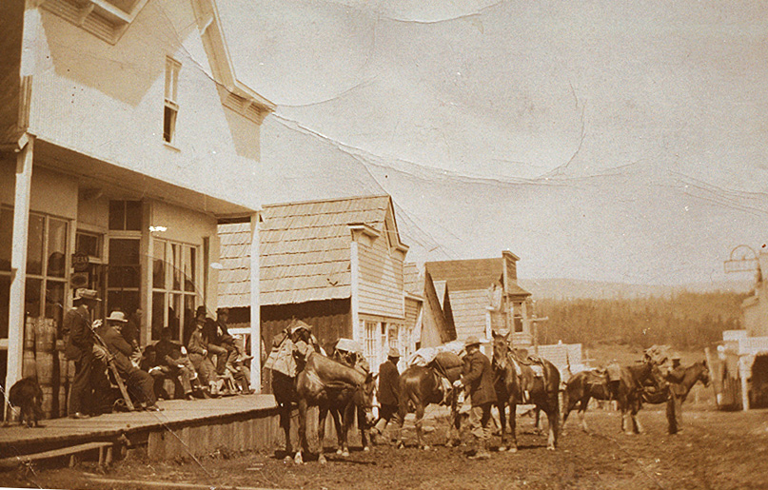
Idaho County Free Press, October 17, 1907:
The old Nez Perce Trail [to Montana] by way of Elk City has … been reopened at a cost of $3000. Elk City is booming. There is a payroll of $500 daily. G.E. Hamilton has founded a newspaper, Mining News. Work on the wagon road has been completed to within 15 miles of the mining camp. Hotel Parr and the Elk Hotel are doing flourishing business as are all merchants.

Idaho County Free Press, January 2, 1908:
From reliable sources we learn that a railroad will be constructed through the Elk, Orogrande, and Buffalo Hump regions. Work is to begin within four months.
It is rumored that the Sweeney mining interests have been sold for $3,000,000 to the Guggenheim people. Work on the Stites-Elk City telephone is progressing rapidly.

Elk City Mining News, July 25, 1908:
The first definite steps ever taken toward bringing a railroad into the mining region are known to have been started. Rumors have been given space in the Mining News in the past, but the publication of rumors sprang more from the hope of being able to stir up something when real news was scarce…. Central Idaho will no longer lap the hands of the pussyfooted North Pacific engineers, the company that for ten years has held the right-of-way through the forest reserve into the heart of the mining country…. Some say the biggest mining boom that was ever pulled off in America will precede the railroad to this place.

Idaho County Free Press, March 25, 1909:
Elk City is having a 20 page booklet printed telling the advantages of residing here. It is well filled with maps, illustrations, etc., and will be distributed around the railroad centers of the Pacific coast and central west.

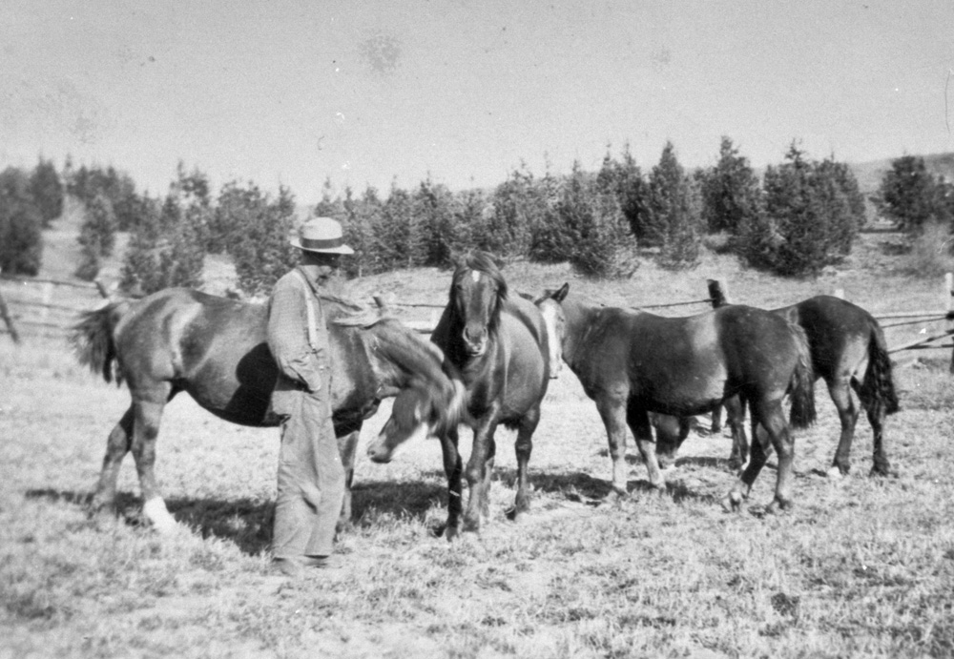
During the first decade of the twentieth century, most of the Litchfield children were reaching adulthood. Grant raised horses on his homestead, then became one of the first rangers in the U.S. Forest Service (1906-1909). Soon the increasing strain of dealing with a bureaucracy led him to resign. He grew wheat and raised horses the rest of his life, and never married.

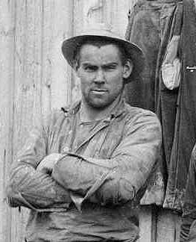
Stanley ranched, mined, ran his own sawmill, and became known as one of the finest axe men and carpenters in the area. Stanley was stubborn, hotheaded, and often ornery, however. In 1909, the county extended the “Old Valley Road” (now Elk Creek Road) north of town through Stanley’s property, despite Stanley’s loud objections. When the county started building a bridge over Big Elk Creek, “persons unknown” wrecked the bridge during the night -- twice. Grant came to Stanley’s aid, and got in a heated argument with two county employees.

Idaho County Free Press, 24 Dec 1908:
It seems about December 8th, [James] Smith and [Richard] Sylvester were building a bridge on a road in [the vicinity of Elk City] and [Grant] Litchfield objected to the same claiming it was on his brother’s property. He kicked a pole from the bridge into the water and was rather rathy. Sylvester and Smith did not appreciate the high handed way of Litchfield and they persuaded him to return the pole and in other ways “tamed” him. No blows were struck, no shots fired, but Litchfield was humiliated….

Since the trouble someone has cut the anchoring of the bridge and allowed the thing to fall into the creek. We understand some arrests will be made soon and the guilty brought to justice. The people of Elk are greatly excited over the row….

Idaho County Free Press, 11 Feb 1909:
This bridge was built by private contributions and those being exhausted the commissioners at the last meeting appropriated money for the purpose of constructing such a bridge and ordered the road commissioner to go ahead with it.

Word was sent out to the sheriff this week that the bridge had again been wrecked and was laying in the bottom of the stream…. The people of Elk and vicinity are tired of the tactics of certain people up there, and feelings are in a high pitch. It’s a good thing to nip such things as this in the bud and possibly prevent a murder.

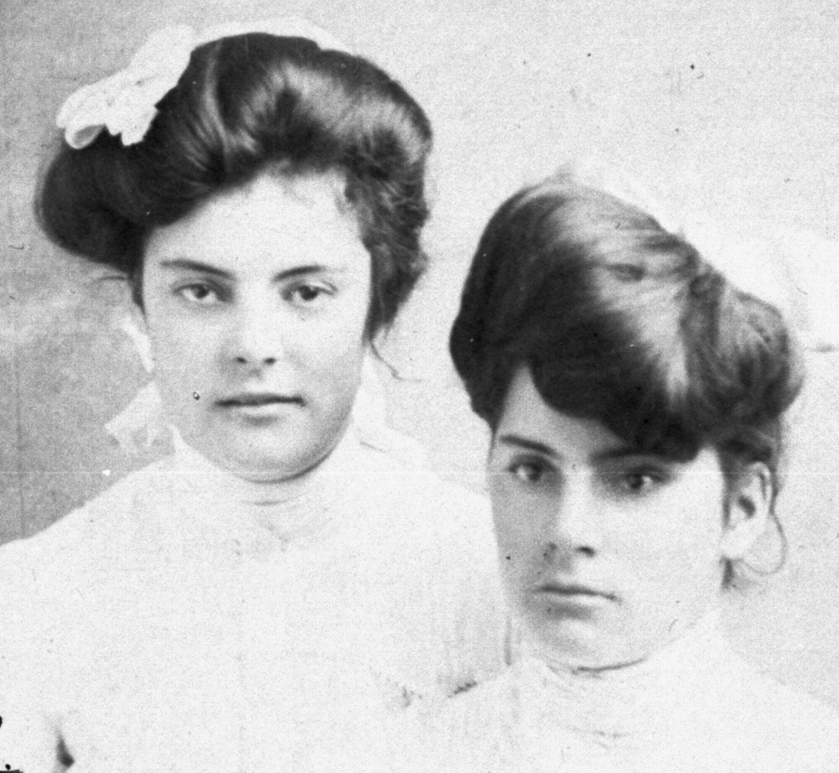
Noël and Alma grew up together, learning from their mother how to behave with more grace than usually found in mining camps. They both loved to ride horses, and they rode quite well and quite often. The photo at the right shows Alma and Noël around 1904.

On 16 Jul 1906, 21-year-old Noël married Laurence Albert Painter in Elk City. Larry was almost 37 years old, had been trained as a pharmacist, but had come to Elk City as an assayer. In 1897, he was one of two men to discover the gold vein that later became the American Eagle Mine. Larry and Noël had two daughters, Helen Elizabeth (b. 13 Dec 1906) and and few years later, Lillian Lee (b. 1 Jul 1908), who was called “Babe.”

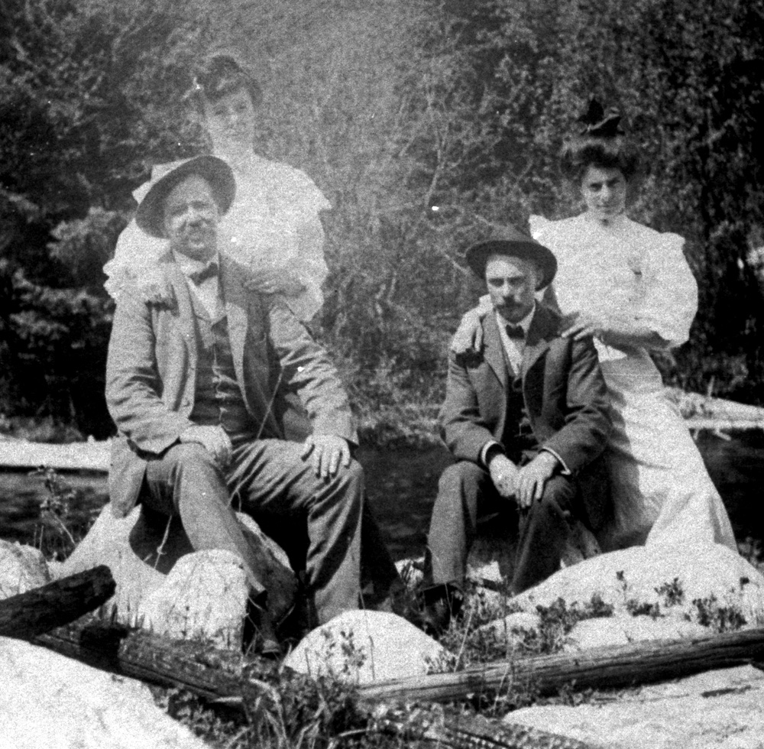
On 29 Sep 1906, 20-year-old Alma followed suit and married Frank J. Hye, a prominent local miner and saloon owner originally from Rhode Island. Frank was 14 years older than Alma and often displayed a bullying manner. The women in the family had misgivings about Frank, and as you will see, these misgivings were justified.

The picture shows Frank and Alma on the left, Larry and Noël on the right, in the summer of 1906. Notice that Frank is the only one smiling.

Idaho County Free Press, 16 Jul 1908:
According to the Elk City Miner things must be running free and easy in that camp. There were so many disorderly [sic] and so many acts of rowdy-ism during the week that the businessmen got together … and organized.
It was decided to have L.A. Painter appointed Justice of the Peace and A.W. Davis as night watchman at a salary of $100 per month…. It was also decided to build a jail and a subscription for that purpose amounts to $130. The businessmen are acting in wise judgement [sic] in the matter as conditions now exist.
Sunday there were several fights and several young savages who came into town and paraded the streets and yelled all night, apparently for no other purpose than to keep the people awake. In the same night two fires were started on the shavings in the new Elk Hotel.

“Buster” Smith’s mine was the first and most successful of the underground mines in the “Quartz Boom” of 1895 - 1913. It was sold in 1908 to outside mining interests for $100,000. This was another example of Buster’s business acumen. He was the first and most successful mine developer in the Elk City Quartz Boom, and he was smart enough to get out while he was ahead.

Idaho Litchfield became a blacksmith and metal worker. He tried to patent a homestead in the Hidden Springs area south of Big Elk Creek, but the land faced north and didn’t get as much sunlight as the homesteads of his brothers. Idaho never proved up on the land, and it was later patented by someone else.

John Arden Litchfield was called “Arden” by most of the family, and later “Blackie” by others. He worked at various mines, and fell in love with a local school teacher named Cora Hansen.

In 1913, Ruth Elizabeth Litchfield married Lee Fruit, a young man from Tonasket, Washington. The marriage was performed by Alma’s husband, Frank Hye, who was by then Elk City’s Justice of the Peace. Lee and Ruth moved to Tonasket and later to Oregon.

By 1913, Elk City’s Quartz Mining Boom was about to go bust. With the primary exceptions of the Buster, the Colonel Sellers, and the American Eagle mines, most of the underground veins yielded little more gold than the initial “discovery” pocket. In the 1910 Census, Elk City had counted 297 inhabitants; by 1920, the count fell to 116.

Tragedy Strikes the Litchfield Family

In 1913, Frank Hye, Alma’s husband, was still betting on boom times ahead. He bought a large chunk of the meadow along Elk Creek, just below the town’s Main Street. This was called “The Hye Addition,” and was platted with seven streets running east and west, named after States of the Union, and four avenues running north and south, named “Gold,” “Silver, “Lead,” and “Copper.” Never mind that the land was a seasonal wetland; Hye had big plans for it. In addition, Hye was in the process of buying the Stites-to-Elk-City Stage Line from Nate Pettibone. Hye was operating the line, but had not finished paying for it. He had financed his deals by selling his Elk City Saloon and signing various notes for a total of $8000 at 12% interest.

Meanwhile, the underground quartz mines were finding a lot more water than gold. As the mines went deeper, the engineers were finding it harder and harder to "dewater" the shafts and tunnels, which were now often 300 feet down. The mine supervisors were finding it more difficult to justify the mounting expenses as production kept dropping, and the mines closed one by one. As a son of the American Eagle’s supervisor said many years later, “This time, Elk City went down hard -- and stayed down.”

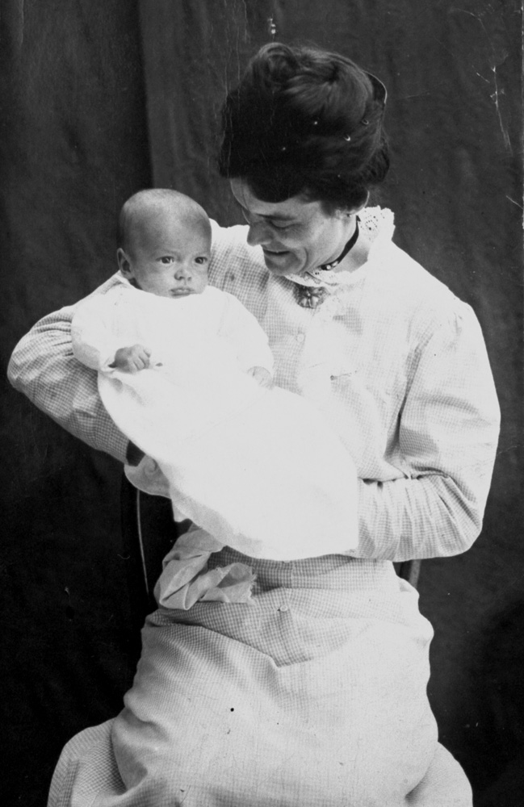
Frank Hye had bet everything he owned that Elk City would boom. He had been one of its big promoters, claiming that 5,000 people would live and prosper in Elk City within a few years, and predicting that a railroad would soon reach the area. Now, in 1914, he was seeing the mines shut down, the freight revenues from his stage line decline, and no buyers for home lots in the Hye Addition. Just then, in January, 1914, his wife gave birth to a baby. Hye allegedly did not want a baby, and apparently did not even know until very late that his wife was pregnant, because he was spending the majority of his time living in Stites at the stage office, or mining in Dixie. Nevertheless, Alma gave birth to a boy on 22 Jan 1914, and Frank pretended to be overjoyed. They named the baby Tommie Francis Hye, after Frank’s brother. But Alma and the baby continued to live in Elk City, while Frank spent much of his time in Stites.

The financial situation did not improve in 1914, and the Post Office delayed in approving a new mail contract for the stage line. By summer, Frank was unable to pay his workers their wages.

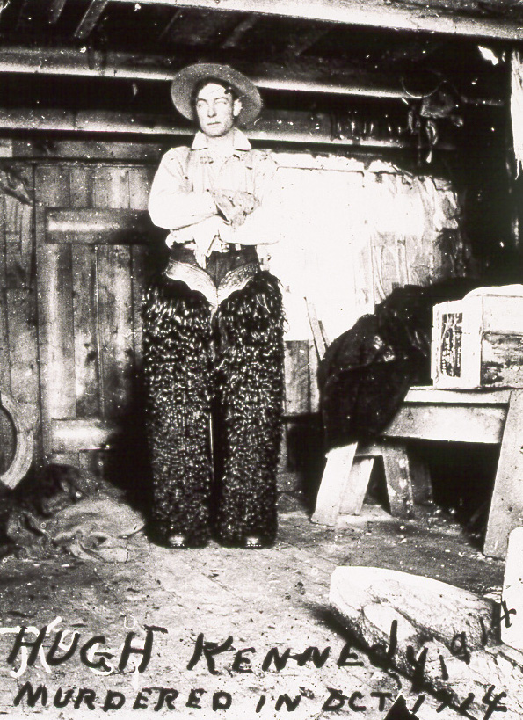
Among the people who were owed money was a popular 20-year-old stage driver named Hugh Kennedy, who was owed more than $100 – pretty big money for those times. As the weeks wore on, Hugh became more aggressive, hunting Frank down at every opportunity and demanding his money. Frank was getting more desperate. Life was closing in on him.

On Sunday evening, 4 Oct 1914, Alma and the baby ate dinner in the Parr Hotel’s restaurant and then returned home a little after 9 p.m. Hugh Kennedy brought in the stage, put the horses and coach away for the night, and asked several people whether they had seen Frank Hye. Hugh said he had seen the tracks of Frank’s horse on the way into town. Then Hugh got a room at the hotel and ate dinner in the restaurant. Exactly when he left the hotel is unclear.

At first it seemed like an ordinary, rainy autumn evening in the little mining town. However, an agitated Frank Hye suddenly showed up at the Parr Hotel around 10:15 p.m., carrying his eight-month-old son. He handed the baby to Maud Baskett, who was in charge, and announced that he had just shot Alma and Hugh Kennedy at his house. According to Frank, he had caught them committing adultery and Hugh had attacked him. Frank said he had a revolver and had shot Hugh in self-defense. He said that Alma had been shot by accident, during the scuffle. While Frank paced back and forth in the hotel lobby, crying “Alma! Alma! Why did you make me do it?”, several townspeople, including Noël, her husband Larry Painter, and Arden’s fiancèe Cora Hansen, ran down to the Hye house in the rain to investigate.

Alma’s 20-year-old brother, Arden, testified later that he had heard several shots from the direction of the Hye house, then a pause, then one more shot. This was about 9:30 p.m. But, he said, “as there was always shooting at night in a mining camp, I paid no attention.”

They found Alma dead on the parlor floor. She was lying on her back, wearing only a camisole, her hands neatly folded on her stomach. There was a single bullet hole in her left breast, a bloody gash above her left ear, a bruise on her chin and face, and a great deal of blood in her hair. Her hat, with a broken hair-comb, lay on the floor. There was blood on the sofa and a bloody smear on the wall behind it, where a head seemed to have hit it. Some clothes were neatly folded on the arm of a chair in the kitchen, but they weren’t the clothes she had been wearing earlier. Hugh Kennedy lay crumpled and dead in the corner of the room. The top buttons of his pants were undone and his belt was unfastened. He was otherwise fully dressed, and was wearing a pair of extremely muddy boots.

Where were the clothes Alma had been wearing when she took the baby up to the hotel for dinner? After a search, the investigators found them burnt in the woodstove. The presumption was that Alma was fully clothed when shot, and Frank didn’t want anyone to see the bullet hole and blood in the clothes. However, Alma’s shoes were found behind the woodstove, with bloody stockings stuffed into them.

Investigation also revealed that Hugh Kennedy had been inquiring all over town for Frank, in an effort to get the back wages he was owed. It was said by one resident that Mrs. Baskett, at the hotel, had sent Hugh down to the Hye house, telling him that Frank was there and he could get his money. Mrs. Baskett denied this, claiming that Hugh had sneaked out of the hotel after pretending to go to sleep in his room. Some people insisted that Hugh was not the sort of man who would have entered a home willingly wearing muddy boots. They surmised that Frank had ambushed Hugh outside the home and marched him inside at gunpoint. Investigators found blood drops on the steps into the house from the woodshed. Two doctors later testified that Hugh had been shot several times in the back.

A few hours after the shootings, it was pointed out to Frank that “the Litchfields are a hot-headed bunch,” and he would be a lot safer in jail in the county seat at Grangeville. Frank, being the Justice of the Peace, deputized a citizen named Hakon F. “Slivers” Thompson to place him under arrest and to take him to Grangeville immediately. Slivers confiscated Frank’s revolver, and he and Frank left in the middle of the night.

After the initial investigation was completed, Alma was prepared for burial. She was buried on the hill above the Litchfield homestead on 8 Oct 1914, at a spot where she had enjoyed reading under the trees as a girl.

A week after the killings, Frank’s older brother Thomas showed up in Elk City on the stage. He and his wife took Frank and Alma’s baby boy to Spokane, where he was later adopted and raised by Frank’s sister, Mary Hye Carlin. The baby was renamed Tommie Francis Carlin.

The Litchfield family probably could not prevent the Hyes from taking the baby. Frank was the only surviving parent, and couldn’t be prevented from acting in that capacity until he was convicted. It is also possible that the Litchfields did not want any child of Frank’s.

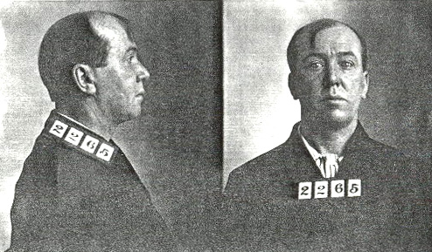
After a long and sensational trial, Frank was convicted of second-degree murder in the death of Alma. (He was never tried for killing Hugh Kennedy.) Frank was sentenced on 10 Mar 1915 to a term of ten years to life in the Idaho State Penitentiary in Boise.
He applied for a pardon in 1916, on the grounds of temporary insanity. The Governor and Secretary of State were at first willing to pardon him, but the Attorney General explained the facts of the case and they changed their minds. Frank applied again in 1917, when there was a new Attorney General. The Governor still voted against pardoning Frank, but the Secretary of State and the new A.G. voted for a pardon and release on the grounds of “temporary insanity and the unwritten law.” A pardon was granted in September but for some reason Frank was not actually released until Christmas Day, 1917.

Although stories have long circulated among the Litchfield and Kennedy families to the effect that Frank Hye was later hunted down and killed in either Mexico or Canada, the facts are quite different. In April 1920, the U.S. Census recorded Frank living in Casper, Wyoming. He died in Casper on 9 Mar 1941, at the age of 71. He is buried in grave 20, lot 6, block 166 of Highland Cemetery, in Casper. So far, we know nothing of his later life.

We do know about the baby, however. Tommie grew up in Spokane and became a military man. After serving in the U.S. Marines and Navy, he found a home in the Army and served in World War II, Korea, and Vietnam, earning three Purple Hearts and the Vietnamese Cross of Gallantry. He retired from the Army as a sergeant in 1978, after 42 years of military service, and died in Waco, Texas in 1992. In later life, he wouldn’t tell anyone, even his wife, about his origins.

Worse and Worse

The decline of Elk City’s prospects, then Alma’s death, followed by the investigation and gruesome trial, tore the heart out of the Litchfield family. A month after Alma’s burial, she was disinterred so that the Coronor could belatedly look for signs of sexual activity just before death, but none were found. Alma’s sister Noël was present during this examination, and it must have been an awful experience. John Charles, Sarah, Noël, and Arden all testified at the trial. Noël’s testimony was especially gruesome. She testified that Frank Hye had never wanted children and that he had kept a set of medical instruments, which he used on several occasions to abort his wife against her wishes. During this testimony, Noël collapsed on the stand. Frank denied any knowledge of the instruments that were found in his home and displayed at his trial.

After Hye went to prison in March, 1915, Sarah sued her brother “Buster” in Federal Court in Moscow, claiming that he had reneged on his agreement to pay John Charles and Sarah $10,000 when he sold the Buster Mine, which he had done in 1908 for $100,000. Sarah was unable to prove her claim, and her brother denied it, so the case was dismissed. During the next few years, Noël, Arden, and Helen left Elk City. (Ruth had already left after her marriage.)

Sarah was never the same after this. Within a few years, she was diagnosed with cancer. She died 23 Nov 1920 at her home and was buried close to Alma on the Litchfield homestead.

J.C. lived six years longer. He died near Elk City on 9 Aug 1926 and is buried between Sarah and Alma in the Litchfield family plot.

Later Lives of the Other Litchfield Children

William Grant Litchfield (“Grant”) never married. He lived out his life raising horses on his property north of Elk City, raising hay, doing a little mining, and working as a packer. He died 10 Aug 1940 of cancer, and is buried in the Litchfield family plot, on the other side of his parents from Alma.

Stanley Watkins Litchfield married Eva Lotta (b. 4 Mar 1874; d. 14 Nov 1939) some time before 1920. Eva was an accomplished pianist and composer, and Litchfield family legend has it that she had played piano in a “bawdy house.” She had previously been married to a man named Holt.

Stanley was a hard worker. He trapped, mined, ran a sawmill, built many buildings, and was famous for his axemanship. He owned the Madre d’Oro Mine on American River, dug 1100 feet of tunnels, but produced little gold. Both Dick Boyd and Al Mitchell, in interviews conducted in 2000-2003, mentioned what a hard worker Stanley was. Al told this story: “One day in the 1930s, a young man happened upon Stanley, who was digging a ditch to bring water down Flatiron Ridge to his mine. The young fellow said, ‘Good heavens, Stanley, that’s quite a ditch. How long is that ditch?’ Stanley replied, ‘Oh, ‘bout seven an’ a half shovels.’ The young man was puzzled. Stanley explained, ‘Well, I wore out seven shovels, and this one’s about half gone too.’”

Stanley died about 3 Dec 1943 when his lumber wagon overturned near his sawmill on American River. He had been rebuilding Elk City’s hotel at the time. (The Parr Hotel had been destroyed in the big 1930 Fire, and then its replacement, The Elk City Hotel, burned in 1939.) Stanley and Eva had no children, and are buried together in the Litchfield family plot.

Noël Arden Litchfield and her first husband, Laurence Albert Painter, had two girls, Helen (born 13 Dec 1906) and Lillian (born 1 Jul 1908). They moved to Sciota, Illinois (Larry’s hometown) after the Hye trial, and then to southern California. After Larry Painter’s death there in 1936, Noël married Earl Spafford, who died in 1975. Noël herself died 13 Mar 1967 in San Bernardino, CA, and is buried there.
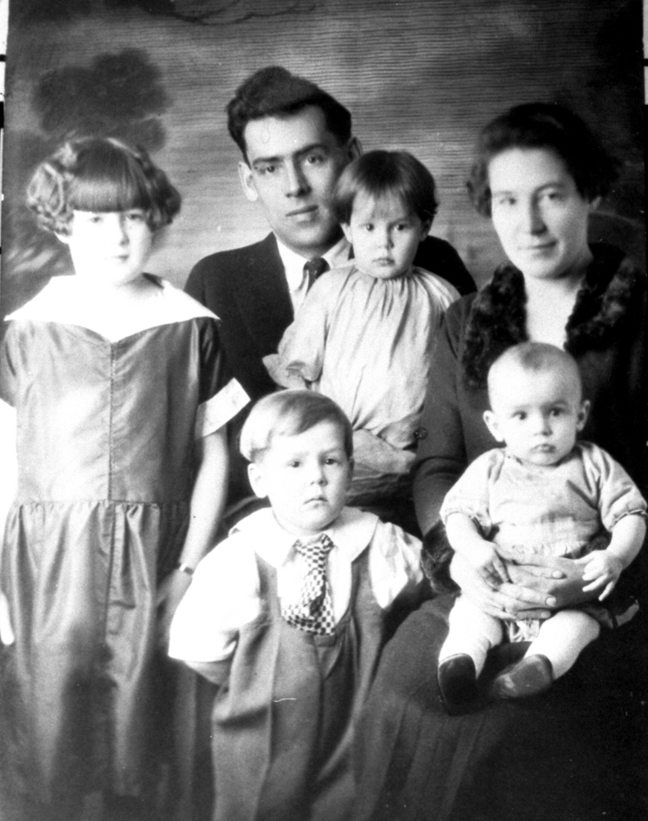
Idaho Charles Litchfield served as a Machinist’s Mate in the U.S. Navy during World War I. After returning home, he met Emma Luella Kimball at a dance in Elk City. They were married in Lewiston, Idaho, 27 May 1922. Idaho worked in various capacities and in various places as a machinist, carpenter, and metal worker. He and Luella had four children: William, Barbara, Robert, and Floyd. (Idaho also adopted Luella’s child by a previous marriage, Francis June Edwards.)

Idaho died June 17, 1961, in the Veteran’s Hospital in Boise. Luella was born Jan. 28, 1898, in Rockford, South Dakota and died Jan. 13, 1979 in Grangeville. Idaho and Luella are buried together in Prairie View Cemetery, Grangeville, Idaho. He wasn’t buried in the Litchfield graveyard because Stanley’s wife was buried there, and Idaho refused to be buried with a “bawdy woman.”

John Arden Litchfield, who was called Arden or “Blackie,” married Cora Mabel Hansen, who had been a teacher in Elk City. Arden worked in mining in the Coeur d’Alene area, and as a government inspector. The couple had one child, John Howard. Arden died 31 July, 1967, in a Spokane hospital. He is buried in Coeur d’Alene with Cora, who died in June, 1981.

Ruth Elizabeth Litchfield left Elk City after marrying Lee Fruit in 1913. The couple lived for some years in his home town, Tonasket, WA, where they raised two children, Virginia and Jack. In later years, Ruth was a designer for Janssen Sportswear in Portland, OR. Ruth and her son Jack remained close, both later changed the spelling of their last name to Fruett. Ruth died 6 Oct 1977 in Multnomah County, Oregon. Ruth’s and Jack’s ashes are buried in the Litchfield family plot near Elk City.

Sarah Helen Lee Litchfield married George Darius Burpee in Grangeville, 27 Oct 1916. Burpee and his father were prominent miners in the Dixie area, and Burpee Mountain is named after them. Helen had no children. She died 20 Aug 1978 in El Segundo, Ca.

The Litchfield Family Plot
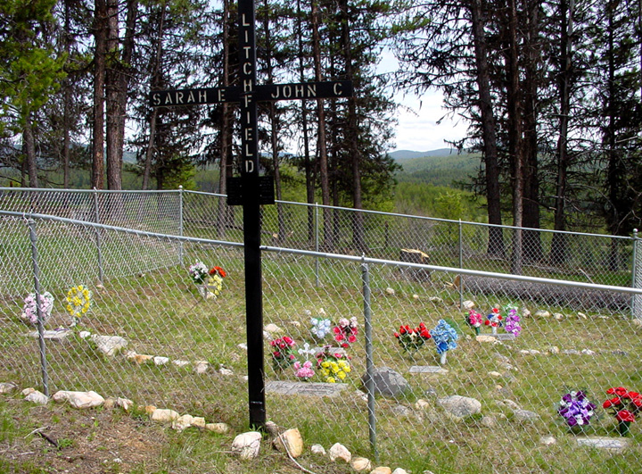
The Litchfield family plot is located on private property 1.8 miles north of Elk City off of Elk Creek Road, at 45º 51’ 5.2” N 115º 26’ 18.7” W. It is not possible to drive to the graveyard. The landowners are ordinarily happy to escort visitors and provide information on Litchfield family history, but ask that visitors get permission before entering the property, which is posted. Phone (208) 842-2664 or send e-mail to bsalmon@wildblue.net.

Sources

In 1998-2005, I interviewed Floyd and Betty Litchfield, Bob and Evie Litchfield, Barbara Litchfield McPeak, and Jerry Litchfield (a grandson of Arden and Cora). I obtained from them many photographs, general information about family members, and the Litchfield family account of the killings of Alma Hye and Hugh Kennedy. I also interviewed Hugh Kennedy, a nephew of the Hugh who was killed.

In 2002, I tracked down information about the later life of Tommie Francis Hye, who had been adopted in 1915 by Mary Hye Carlin. I interviewed Tricia Dibblee, of Beaverton, Oregon, who is descended from Mary Hye Carlin and knew “Uncle Tommie” slightly when she was a girl. I also interviewed that year Helen Troll, of Bedford, Texas, and Bettye Spears, of Waco, Texas, who were, many years later, step-daughters of Thomas Francis Carlin. They told me that their step-father had always kept his origins a secret, even from their mother.

There is an interesting undated statement by Angus L. Kennedy, who relates family stories of the murders. He also relates what he was told by Effie Mae Miller, who was in Elk City at the time and knew both of the victims.

A letter from Idaho Department of Corrections to Floyd Litchfield, postmarked August 8, 1990, stated that Frank Hye, prisoner #2265, claimed to be 43 years old when received at the Idaho State Penitentiary on March 14, 1915. (So he was born in 1871 or 1872.) Frank stated that he had been born in Providence, Rhode Island. He said that he had a brother, Thomas, living in Spokane, but did not mention a sister. He mentioned that he had a son, but did not give the boy’s name or say where the boy was at that time.

A note from Sarah Litchfield, apparently written soon after the events, described the last times she saw Alma alive, and gave the burial dates.

Harriet Fish Backus, the wife of a prominent mining engineer, gave a personal description of Alma and Frank in her memoirs, Tomboy Bride (Pruett Publishing, Boulder, CO; 1977). The names are changed to protect all parties concerned. Alma is called “Nan Cane,” and Frank is called “Bert Cane.” Some of the dates and minor details are incorrect, but the bulk of the story agrees with other sources.

Newspaper accounts of Frank Hye’s trial are available online at
http://www.rootsweb.ancestry.com/~ididaho/murders/hye_murder.htm
and many of them are in the book, Over a Century of Murder in Idaho County, published by the Idaho County Historical Society and The Bicentennial Historical Museum in 2006.

I checked all available leads in trying to find out where Frank Hye went after he was released from prison at the end of 1917. I could find no record of his death in Canada, which was suggested by the Kennedy family. There is no good way to check death records from that period in Mexico, which was suggested by the Litchfield family. Frank’s brother and sister were still in Spokane at the time of his release, and the Idaho Department of Corrections had only a Spokane address for him. However, searches in Spokane newspapers and in Washington State Death Records turned up no record of Frank Hye’s later life or death there. There is also no record of his death in California, where his brothers and sisters lived in later years, or in Rhode Island, where Frank grew up.

Eventually, the 1920 U.S. Census Index was published by Ancestry.com and I learned that a Frank Hye, born in Rhode Island about 1871, lived in 1920 in Casper, Wyoming. With the help of a USGenWeb volunteer, I learned that Hye died in Casper in 1941. His grave location was confirmed by the reference librarian at the Natrona County Library, but she was unable to find an obituary for him. The details of Frank’s later life are still unknown. He is not listed in the 1930 U.S. Census.

Searches for information about Frank J. Hye are aided by the rarity of this name. During the period in question, there seem to have been only three other people in the United States named “Frank Hye.” One was an African-American who lived and died in Louisiana. Another lived in Maryland and had a son of the same name. None of those people were born in Rhode Island, and none had lived in the west.

-By Bill Salmon

Litchfield family notes. Also, Sister M. Alfreda Elsensohn, Pioneer Days in Idaho County, vol 1 (Caxton, 1947), page 166.
Francis A. Thomson and Samuel M. Ballard: Geology and Gold Resources of North Central Idaho. Bulletin #7 of Idaho Bureau of Mines and Geology, 1924. Pages 61-63. Material was reprinted in P.J. Shenon and J.C. Reed: Geology and Ore Deposits of the Elk City, Orogrande, Buffalo Hump, and Tenmile Districts, Idaho County, Idaho. Circular 9, U.S. Dept. of the Interior, Geological Survey, 1934. Pages 39-40.
From material in the possession of Litchfield family members. The name of J.C.’s ship is based on a pair of antique binoculars inscribed with that name, still in the possession of the Litchfield family. The description of the ship is available on the Internet.
According to members of the Litchfield family (personal communications.)
Some of this is based on Litchfield family materials, supported by Census enumerations found with the help of Ancestry.com. For first-hand observations about Sarah’s personality, see Harriet Fish Backus: Tomboy Bride (Pruett Publishing, Boulder, CO; 1977), pages 200-202. In that book, Backus changes Sarah’s name to “Mrs. Glade” in an effort to spare embarrassment to those who were hurt by Frank Hye.
From the 1880 U.S. Census enumeration page, obtained through Ancestry.com.
Birthdates from Litchfield family records, supported by Census data. Early records show Noel’s middle name as Arden, but her California Death Record from 1967 shows her middle initial as “M,” and a memorial tribute to her daughter Helen gives Noel’s middle name as “Mizpah.” The significance of this is unknown.
From an undated letter written by Noël’s daughter Helen E. Park to Bob and Evie Litchfield. Also from the memorial tribute to Helen E, Park written by her friend, Marilyn Gilbert, 5 Feb 2002.
The railroad was The Milwaukee Road, and its “Route of the Hiawatha” wasn’t completed over Lookout Pass until 1906. See http://www.ridethehiawatha.com/hiaw/
The federal land patents obtained by John Charles, Grant, and Stanley Litchfield are available online at http://www.glorecords.blm.gov/PatentSearch/Default.asp? Maps of these patented lands are available at http://www.rootsweb.ancestry.com/~ididaho/PHOTOS/EC_Land_Patents1.JPG and http://www.rootsweb.ancestry.com/~ididaho/PHOTOS/EC_Land_Patents2.JPG
Sister M. Alfreda Elsensohn, op. cit. Some sources give Idaho Charles’ birthdate as 29 Oct 1889 but family sources insist it was 30 October.
Idaho County Free Press, issues of 19 May 1893, 19 Jul 1895, and 9 Sep 1898. Also from Litchfield family records.
Sister M. Alfreda Elsensohn, op. cit., pages 166-167, gives the date as 1895 and says there were “seven pupils, including Lee Mann, the Chinaman, and members of the Litchfield family.” In 1895, only the first five Litchfield children were old enough to go to school. Helen E. Park, the older daughter of Noel, wrote much later in an undated letter to Bob and Evie Litchfield that there were eight pupils, four Litchfields and four Shisslers, but I cannot find evidence that Shisslers were living in Elk City at that time.
Sister Elsensohn wrote on page 34 of volume 2 of Pioneer Days in Idaho County that Grant Litchfield was the first ranger at the Red River Ranger Station. However, Grant was 56 years old when Red River Ranger Station was built in 1937. Bob Litchfield, Grant’s nephew, said that Grant was in fact the first ranger at the Elk City Ranger Station. (Personal communication, 1998) Cindy Schacher, a Nez Perce National Forest Archeologist, was able to determine for me that Grant was a ranger from 1906-1909. Around 1909, the Forest Service became more formal and required its rangers to pass various exams.
Personal communications from Floyd Litchfield, Bob Litchfield, and Barbara Litchfield McPeak, 1998-2000.
Harriet Fish Backus: Tomboy Bride (Pruett Publishing, Boulder, CO; 1977), pages 189 and 200-202. In that book, Noël is called “Abby Ballington” and Alma is called “Nan Cane.”
P.J. Shenon and J.C. Reed, Geology and Ore Deposits of the Elk City, Orogrande, Buffalo Hump, and Tenmile Districts, Idaho County, Idaho - Circular 9 of the U.S. Geological Survey (1934), page 35, citing information from Ed Condit and the mine’s former superintendent, A.W. Boyd.
Noël’s wedding was reported in the Idaho County Free Press, July 19, 1906. The date of Helen E. Painter’s birth was found in the memorial tribute written after her death by her friend, Marilyn Gilbert, in 2002, and also in her Social Security Death Record. Lillian Lee Painter’s birthdate was written by her sister on the back of a photograph that I was allowed to copy by the Litchfield family. The inscription also said that Lillian’s married name was Wright, and that she died 5 May 1955. I have found no records of this on Ancestry.com.
Harriet Fish Backus called Frank Hye “Bert Cane,” and described him as “heavy-set, smooth-mannered, smug, always half smiling, somehow obnoxious.” Backus, op. cit., page 189. Compare to the picture shown above on page 5.
Idaho County Free Press, “Mrs. Litchfield of Elk City Loses Suit,” May 20, 1915.
Idaho Litchfield tried to homestead in 1911 on the hillside south of Big Elk Creek, in T 29N, R 8E, Sec. 15, B.M. The land was pointed out to me by both Floyd and Bob Litchfield, two of Idaho’s sons. Gertrude Maxwell mentions Idaho’s difficulties with the property on page 21 in her book, My Yesterdays in Elk City (Idaho County Free Press, 1986). She misidentifies Idaho Charles as “Charles J. Litchfield” on page 25 in the list of homesteads. According to the BLM’s General Land Office records, the property was later patented in 1920 by Lon Dean. It can be seen in the maps available online at http://www.rootsweb.ancestry.com/~ididaho/PDF/ElkCityPatentMap1.htm
Personal communication from Jerry Litchfield, grandson of Arden. Also mentioned by the sources listed in note 8.
Idaho County Free Press, August 14, 1913. Later information from 1920 and 1930 U.S. Censuses.
From a taped interview of Dick Boyd, made in 2000. Dick was the younger son of “Doc” Boyd, who had come to Elk City in 1906 as superintendent of the American Eagle Mine. After the American Eagle played out, Doc and his two sons explored gold prospects all over the area. Dick was born in Spokane in 1916, came to Elk City in 1922, and actively prospected and mined off and on from the early 1930s until the 1960s.
From the 1910 and 1920 U.S. Census enumeration sheets, obtained through Ancestry.com.
The “Hye Addition” was still shown on the Elk City plat as late as 2004.
From Idaho County District Court documents filed 22 Feb 1916, seeking to recover lender’s costs by foreclosure and sale of Frank Hye’s tangible assets.
From a taped interview of Dick Boyd, made in 2000. See note 24.
The information that follows was taken from the extensive newspaper reporting in the Idaho County Free Press: “Tragedy at Elk Ends in Double Killing,” October 8, 1914; “Hye Will Answer to Charge of Murder,” October 15, 1914; “Hye Out on Bonds,” October 19, 1914; “Preliminary Held Behind Closed Doors,” October 22, 1914; “Hye Gave $4000 Bonds But Is Arrested On Second Charge,” November 12, 1914; “Jurymen Drawn and Summoned,” February 4, 1915; “More Jurors Are Summoned,” February 18, 1915; “Hye Trial Opened Monday,” February 25, 1915; “Hye Tells His Story to the Jury,” March 4, 1915; “Intense Interest Manifested in Trial,” March 4, 1915; “Sentence of Ten Years to Life,” March 11, 1915; “Prisoners Taken to Boise,” March 18, 1915; “Frank Hye a Musician,” March 25, 1915; “Mail Contract To Be Re-Let,” April 1, 1915; “Hye Pardoned,” September 27, 1917.
Idaho County Free Press, “Intense Interest Manifested in Trial,” March 4, 1915, in the section entitled “Heard Shots at 9:30.”
Tricia Dibblee, of Beaverton, Oregon, is descended from Mary Hye Carlin and is the family historian. She was able to furnish some information about Tommie’s adoption. Also, I obtained from the U.S. Social Security Administration Tommie’s original Social Security application, filed 4 Dec 1936. Here he lists the date and place of his birth and the names of his (adopted) parents. He signed the document “Tommie Francis Carlin.”
Frank Hye was listed in the 1920 U.S. Census in Casper, Wyoming, saying that he was a U.S. Mail contractor. Nothing is known of Frank Hye’s activities in later years, but a USGenWeb volunteer and the Natrona County Library were able to determine Hye’s death date and grave location as described in the text.
Personal communications from Tricia Dibblee, of Beaverton, Oregon, who is descended from Mary Hye Carlin, and from Helen Troll, of Bedford, Texas, and Bettye Spears, of Waco, Texas, who are both step-daughters of Tommie Francis Carlin. Tommie’s obituary appeared in the Waco Tribune-Herald, 31 Aug 1992. It gives the basic facts of his military service.
Idaho County Free Press, “Hye Trial Opened Monday,” February 25, 1915; “Intense Interest Manifested in Trial,” March 4, 1915.
From stories in the Litchfield family and also from reference 20.
Idaho Death Index, record #032615
Date from family sources; no Idaho Death Index listing found.
Grant’s death date from Idaho Death Index #120586 and from the memorial album used at his funeral.
Eva’s birth and death dates from Idaho Death Index #116795. The story about the “bawdy house” was told to me by three of Idaho’s children. The idea that Eva had been previously married comes from the name “Eva L. Holt” written on some of her sheet music.
According to Shenon and Reed, page 41, there were 1,100 feet of tunnels but there had been no production by 1934. However, Victoria E. Mitchell, Ruth E. Vance, and Earl H. Bennett, in Mines and Prospects, Elk City Quadrangle, Idaho, 2nd edition (Idaho Geological Survey, n.d.), lists the Madre d’Oro as having produced 501-1,000 ounces of gold and less than 50 ounces of silver over the years.
The story about Stanley’s ditch was told by E.F. “Al” Mitchell in a taped interview, 2002.
Stanley died by himself near his sawmill on American River and wasn’t found until a day or two later. The approximate date of his death comes from family records and Idaho Death Index #136902.
A new Elk City Hotel was built on the site of the Hotel Parr after the fire of 1930, but the replacement burned during the evening of Saturday, 25 Feb 1939. One of the firefighters was a young miner from Orogrande named Gordon James, who described it in a letter to his fiancee. The letter is still in the possession of their daughter, Karel James Fisher, of Salmon, Idaho.
Most of this information came from Helen Painter Park, who wrote some of it in an undated letter to Bob and Evie Litchfield. Some more appeared in a memorial tribute to Helen after her death, written by Marilyn Gilbert, 5 Feb 2002. The 1920 and 1930 U.S. Censuses list Larry, Noel, Helen, and Lillian living in Illinois. Noel’s death date was confirmed from Social Security Death record #547225152 and California death record #547225152.
Idaho and Luella’s marriage date was confirmed from Nez Perce County marriage records and Ancestry.com’s online database, Idaho Marriages, 1842-1996.
Personal communications from Bob Litchfield, Floyd Litchfield, and Barbara Litchfield Mceak, Idaho’s children.
Idaho Litchfield’s WWI rank in the U.S. Navy and his dates were taken from his headstone in Prairie View Cemetery, Grangeville, Idaho.
Luella’s dates are from her headstone in Prairie View Cemetery and Social Security Death Record #543261747.
I was told this story separately by Idaho’s children Bob, Barbara, and Floyd.
They were married 25 Sep 1920 in Lewiston, Idaho, according to Ancestry.com’s online database, Idaho Marriages, 1842-1996.
Arden’s death is listed as Washington Death record 018887, and in Social Security Death Index #519205175. Cora is listed in Social Security Death Index #519823868.
Information about Ruth’s later life was provided by her granddaughter, Marguerite Morgan, of Vista, California. At the end of her life, Ruth was once more using her maiden name, “Ruth Elizabeth Litchfield”: see Oregon Death Record #77-16209; Social Security Death Index #540109301. Ruth’s ashes, and those of her son Jack, were buried in the Litchfield family plot in the summer of 2001.
Sarah Helen Lee Burpee: California Death Index #565076340.

